Thomas Towson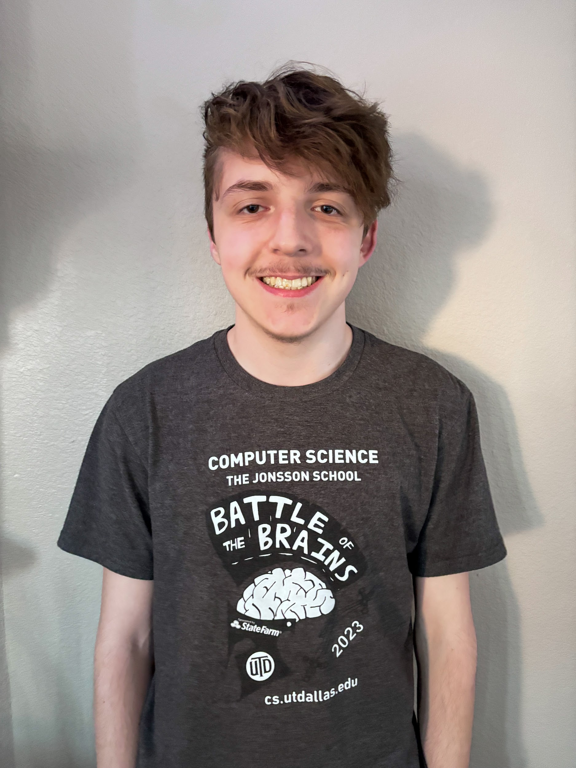

thomastowson2007@gmail.com

Junior

The University of Texas at Austin

This year, I worked on creating the game’s quest system and NPCs, as well as contributing to the creation of UI elements such as the start menu and death screen. Additionally, I contributed to the creation of the game’s title and integrating systems into the game’s final build. The quest system includes quest managing, location triggers, location markers, item retrieval, item receiving, quest updating, saving, loading, player progression, and menus related to the quest system. NPCs include dialogue NPCs that the player can talk to, quest NPCs that give the player quests and rewards for completing them, and wandering NPCs that wander around the game’s levels.